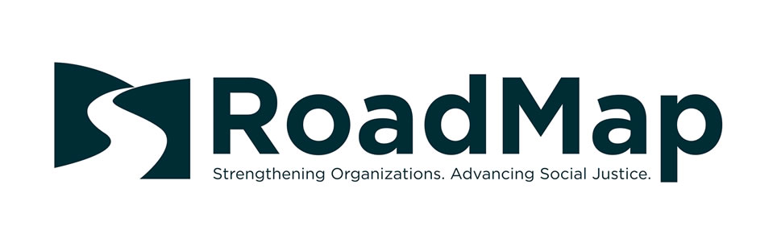Harassment Bullying Sample Policy

Anti-Discrimination, Anti-Harassment/Bullying, and Affirmative Action

Discrimination Prohibited
[Insert organization name] does not discriminate unlawfully on the basis of perceived or actual race, color, religion, sex, gender, gender identity, national origin, ancestry, age, physical or mental disability, legally protected medical conditions including pregnancy and childbirth-family care status, veteran status, marital status, sexual orientation or identification, or any other basis protected by law. [Organization name] prohibits discrimination against or harassment of any individual on any of the bases listed above. For information about the types of conduct that constitute harassment, please see the “Harassment” section below. This policy applies to all areas of employment, including recruitment, hiring, training, promotion, compensation, benefits, transfers. It is the responsibility of every supervisor and employee to conscientiously follow this policy. Any employee having any questions regarding this policy should contact their supervisor or the Executive Director. Any employee who is subject to or witnesses discrimination or harassment that violates this section should promptly contact a supervisor or the Executive Director. Any such employee may file a complaint as set forth in the “Problem Resolution” section of (Organization name) personnel policies and/or employee handbook.

Harassment Prohibited / Anti-Bullying Policy
[Organization name] is committed to providing a workplace free of sexual harassment, which includes but is not limited to harassment based on perceived or actual gender, gender identity, pregnancy, childbirth, or related medical conditions, as well as harassment based on such factors as race, color, creed, national origin, ancestry, age, physical disability, mental disability, medical condition, marital status, sexual orientation, family care or medical leave status, veteran status, or any other basis protected by law. [Organization name] strongly disapproves of and will not tolerate harassment of employees by supervisors or co-workers. Similarly, [Organization name] will not tolerate harassment by its employees of non-employees with whom [Organization name] employees have a professional relationship. [Organization name] will also make diligent efforts to prevent and protect employees from harassment by non-employees in the workplace.

Harassment Defined
Harassment may take the form of verbal, physical, or visual conduct related to any of the legally protected bases described above. Such conduct constitutes harassment when: 1. Submission to the conduct is made either an explicit or implicit condition of employment; 2. Submission or rejection of the conduct is used as the basis for an employment decision; 3. The conduct interferes with an employee's work performance; or 4. The conduct creates an intimidating, hostile, or offensive work environment. Harassment may include, but is not limited to, the following: slurs, jokes, statements, or gestures; assaults; impeding or blocking another's movement or otherwise physically interfering with normal work; and pictures, drawings, or cartoons based upon an employee's protected status. Sexually harassing conduct in particular includes all of these prohibited actions as well as other unwelcome conduct, such as requests for sexual favors, conversation containing sexual comments, and other unwelcome sexual advances. Sexually harassing conduct can be by a person of any gender or sex, towards another person of any gender or sex.

Reporting and Investigating Harassment
[Organization name] understands that victims of harassment are often embarrassed or reluctant to report acts of harassment for fear of being blamed, concern about being retaliated against, or because it is difficult to discuss sexual matters openly with others. However, no employee should have to endure harassing conduct, and therefore, [Organization name] strongly encourages employees to promptly report any incidents of harassment so that corrective action may be taken. Any incidents of harassment, including work-related harassment by [Organization name] personnel or any other person, should be reported to your supervisor, the executive director or to the Chairperson of the Board of Directors for investigation. Harassment complaints may be filed using the procedures described in the “Problem Resolution” section of this handbook or through any other formal or informal method. Any employee who receives a complaint or who observes harassing conduct should immediately inform a supervisor, the executive director or the Chair of the Board so that an investigation may be initiated. Every reported complaint of harassment will be investigated thoroughly and promptly and handled in as confidential a manner as possible consistent with a full, fair, and proper investigation.
It is important to create more than two independent channels of reporting, one that utilizes the usual levels of management and one that provides an anonymous channel to report harassment, discrimination, and potential whistleblower issues. Typically, the investigation will include the following steps: an interview of the employee who lodged the harassment complaint to obtain complete details regarding the alleged harassment; interviews of anyone who is alleged to have committed the acts of harassment to respond to the claims; and interview of any employees who may have witnessed, or who may have knowledge of, the alleged harassment. The Chair of the Board will notify the complainant of the results of the investigation. In addition to notifying [Organization name] about harassment or retaliation complaints, affected employees may also direct their complaints to the [Insert the State Agency that handles these complaints] which has the authority to conduct investigations of the facts. The deadline for filing complaints with the [State Agency] is one year from the date of the alleged unlawful conduct. If the [State Agency] believes that a complaint is valid, the [State Agency] may seek an administrative hearing before the [State Agency] or file a lawsuit in court. Both the [State Agency] and the courts have the authority to award monetary and non-monetary relief in meritorious cases. Employees can contact the nearest [State Agency] office or by checking the state government listings.

Retaliation Prohibited
[Organization name] will not tolerate retaliation against any employee for making a good-faith complaint of harassment or for cooperating in an investigation. No adverse action will be taken against any individual for good-faith reporting of harassment. Retaliation by any [Organization name] employee against an individual reporting harassment is an unauthorized violation of [Organization name] policy, and will lead to disciplinary action.

Corrective Action
If harassment or retaliation is established, [Organization name] will take corrective action that may include, for example: training, referral to counseling, or disciplinary action ranging from verbal or written warnings to termination of employment, depending on the circumstances.

Harassment by External Stakeholders or Vendors
[Organization name] takes seriously any reports of harassment by external parties such as clients, vendors, funders, or contractors. Anyone in management who receives such a complaint should advise the Executive Director immediately. Management shall take immediate steps to de-escalate the situation, remove the offender, and safeguard all employees. In the case of workplace violence, 911 should be called. Management shall work with the target of the harassment to identify next steps and to determine whether or not law enforcement should be contacted. Management shall investigate and take appropriate steps to address the situation depending on the severity of the offense. Steps may range from issuing a warning, cancelling service, getting a restraining order, and/or taking legal action.

